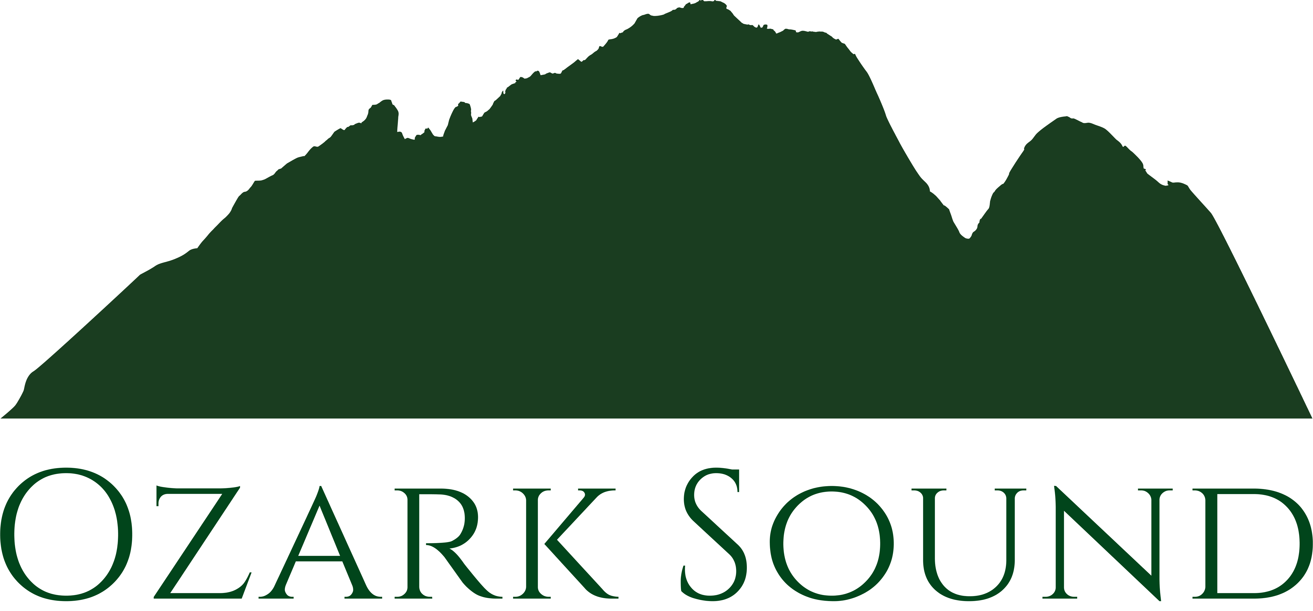

Live Sound & Music Services
479-644-5797 ozarksound@gmail.com

Couple

Contact Information - Phone: Email:
Wedding Planner

Date of Wedding

Location of Ceremony

Number of Guests Approximate Length of Ceremony

Services Needed
Sound System Yes No
Microphones Yes No
Recorded Music Yes No
Live Music Sound Yes No
Sound for Musicians Yes No
Sound for Singers Yes No

Location of Reception

Number of Guests Approximate Length of Reception

Services Needed
Before Dinner Music/Cocktail Hour Yes No
Dinner Music Yes No
Dance Music Yes No
Wedding Party Announcements Yes No
Cake Cutting, Bouquet, Garter Yes No
Special Dances: First Dance, Father/Daughter Yes No
Dance Floor Lighting Yes No

Other Special Needs

